**CHAPTER 3**

**Analysis and Design**

* 1. **System requirements (Functional and Non-Functional)**

**Functional Requirement:**

Functional requirements are responsible for the behaviour of your website and can vary as per the needs and business industry niche. For e.g. the fashion e-commerce stores lets the customers choose different item attributes such as colour, size, sleeves, etc.; on the other side the travel companies may require a chatbot for providing user assistance, luxury goods or jewellery brands come with a zoom option on the product detail page. Here are the other important functional requirements that you must consider for your e-commerce store:

**1.1 3rd Party Integrations:**

It is important to know which 3rd party integrations you will require on your newly developed e-commerce site. This functional requirement focuses on streamlining business operations such as ERP, CRM, PIM, and flexible payment gateways for the customers on your website. Determining the right 3rd party integrations for your website will make it structured and ready for business scaling in the future.

**1.2 Mobile Responsive:**

In today’s era, the most number of users for the website are coming through mobile devices especially smartphones. The numbers are only going to increase in the future. Thus investing in the development of a mobile-responsive website can earn you more than a few bucks. You will also get increased customer loyalty from the customers base.

**1.3 Stock Report:**

Product the quantity of the products available and status of the product

**1.4 order Report:**

List of the products that can be bought by customers. who can buy?

**1.5 Delivery Report :**

List of the products that can be delivery to customer.

**1.6 Registration :**

Customer wants to buy the product then he/she must be registered, unregistered

**1.7:Cart:**

Customer wants to buy more then one product then he/she add into the cart and buy more products.

**1.8 Login:**

Customer wants to buy the products then he/she must be login using there credential if do not have login credential first register.

**1.9: Wish List:**

Customer like any products and went to purchase after some time then he/she add into wish list.

**1.10: Payment :**

If customer buy any products he/she can pay by using any kind of methods.

**1.11 Filtering:**

There are a number of filter in website by using filter customer find products of there choice and brand.

1.12 Search:

Customer search product by using different keyword.

**Non-functional requirement :**

As mentioned earlier, non-functional requirements articulate the quality attributes of the website that build positive user experience and optimal website performance. There are many other types of NFRs, all of which can have a critical impact on the performance, scalability, and usability of your e-commerce platform. These include:

* **Security** – it is important to specify the level of security that should be met such as the OWASP top 10
* **Privacy** – meeting basic requirements for GDPR
* **Scalability and performance** – ensuring that the system can scale to meet expected traffic and order volume at normal and peak times
* **Speed of web services** – defining how long web services will take to provide a response
* **Accessibility** – ensuring that the platform meets the basic accessibility standards throughout
* **Documentation** – ensuring that the platform is sufficiently documented
* **Quality** – even the best e-commerce platforms can be used badly so you should insist that code is developed to a good quality standard
* **Extensibility** – ensuring that the platform is extended in such a way to make future development feasible
* **Data integrity and retention** – defining how long [data should be stored](https://www.the-future-of-commerce.com/2021/04/20/customer-data-management-strategy-best-practices/) and how the integrity of data is maintained
* **Testing** – defining how unit testing will be built into the solution
* **Compatibility** – ensuring that the platform can be easily integrated with 3rd party systems
* **Availability** – defining the agreed uptime of the platform under normal conditions
  1. **: ERD**

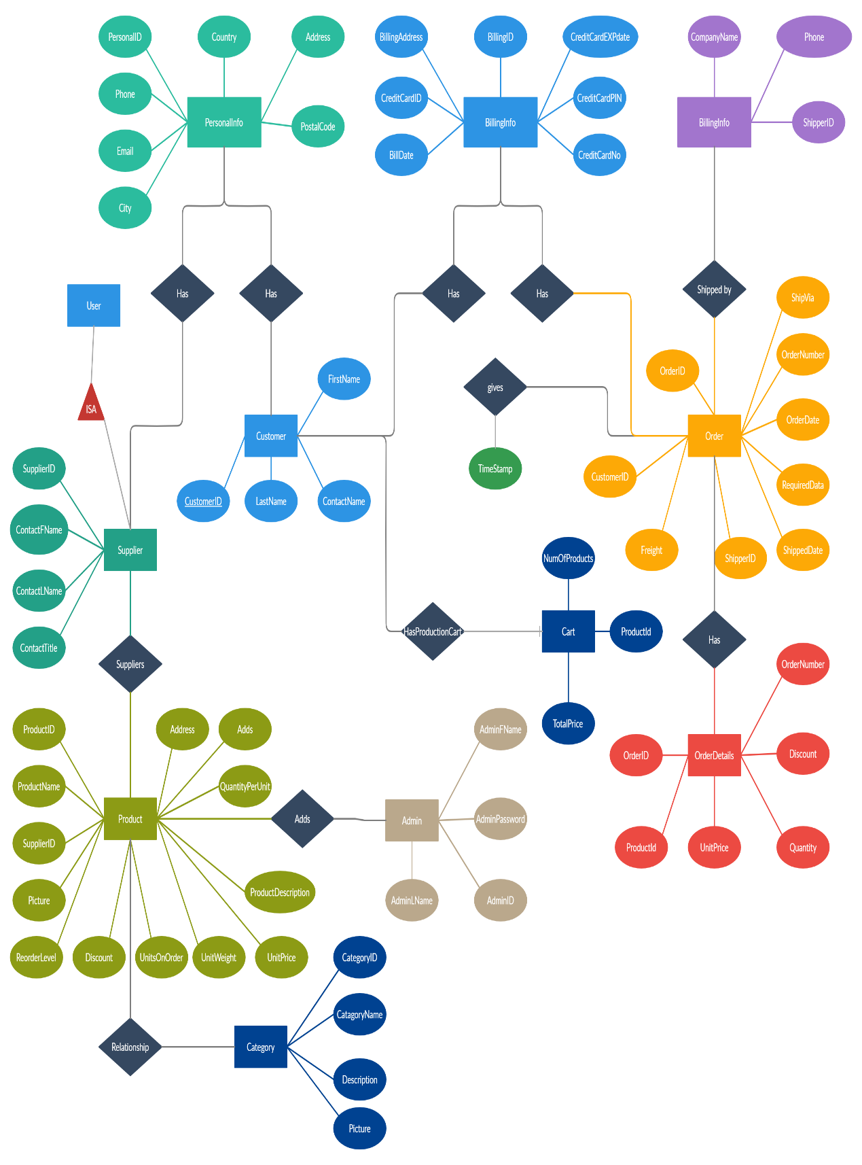

* 1. **: Table Structure:**

**Data Dictionary:**

|  |  |  |  |  |
| --- | --- | --- | --- | --- |
| Field Name | DataType | Size | Constraints | Descriptionn |
| Address | VarChar(40) | 40 | Not Null | Store The Address |
| Billing_Address | VarChar(30) | 30 | Not Null | Store Billing Address |
| Billing_Date | Date | - | Allow Null | Store Date |
| Billing_id | Int(10) | 10 | PK | Store Bill Id |
| C_date | Date | - | Allow Null | Store Date Of the Order |
| C_Id | Int(20) | 20 | PK | Store Customer Id |
| C_Email | VarChar(30) | 30 | Not Null | Store Email Address |
| C_Name | VarChar(30) | 30 | Not Null | Store Customer Name |
| Cart_id | Int(10) | 10 | PK | Store Cart Id |
| Category_id | Int(10) | 10 | PK | Store the Category Id |
| Category_Name | VarChar(20) | 20 | Not Null | Store The Category Name |
| City | VarChar(30) | 30 | Not Null | Store City Name |
| Country | VarChar(30) | 30 | Not Null | Store Conutry Name |
| CreditCardNo | Int(40) | 40 | Allow Null | Store CreditCar Number |
| CreditCartId | Int(30) | 30 | Not Null | Store Cart Id |
| Cust_Id | Int(10) | 10 | Not Null | Store Customer Id |
| Description | VarChar(30) | 30 | Not Null | Store Product Discription |
| Discount | VarChar(20) | 20 | Not Null | Store Discount |
| Email | VarChar(30) | 30 | Not Null | Store Email |
| Order_Date | Date | - | Allow Null | Store Date |
| Order_id | Int(10) | 10 | PK | Unique Identification of the Order |
| Order_Number | Int(10) | 10 | Not Null | Store Order Number |
| P_Description | VarChar(30) | 30 | Not Null | Store the Discription |
| P_id | Int(10) | 10 | PK | Store Product Id |
| P_Name | VarChar(20) | 20 | Not Null | Store Product Name |
| P_Quantity | Int(20) | 20 | Not Null | Store Product Quantaty |
| Personal_id | Int(10) | 10 | PK | Store Personal Id |
| Phone | Int(30) | 30 | Allow Null | Store Phone Number |
| Picture | Attachment | - | Not Null | Store Picture |
| Quantity | Int(30) | 30 | Not Null | Store Stock Quatity |
| S_id | Int(10) | 10 | Pk | Unique Identification of Supplier |
| S_Mobile | VarChar(13) | 13 | Not Null | Store Supplier Phone Numnber |
| S_Name | VarChar(30) | 30 | Not Null | Store Suppiler Name |
| S_Pname | VarChar(30) | 30 | Not Null | Store Supplier Product Name |
| Supllier_Date | Date | - | Not Null | Store Supllier Date |
| Supllier_Id | VarChar(30) | 30 | Not Null | Store Supplier Id |
| TotalPrice | Int(30) | 30 | Allow Null | Total Price Of the Products |
| U_id | Int(20) | 20 | Allow Null | Store Id |

* 1. **: Customer**

|  |  |  |  |  |
| --- | --- | --- | --- | --- |
| Field name | Data Type | Size | Constraints | Discription |
| C_id | **Int** | **20** | **Pk** | **Unique Identification of the Customer** |
| C_Name | **VarChar** | **30** | **Not Null** | **Store Customer Name** |
| C_Email | **VarChar** | **30** | **Not Null** | **Store Customer Email** |

**1.2: Supplier:**

|  |  |  |  |  |
| --- | --- | --- | --- | --- |
| Field Name | Data Type | Size | Constraints | Description |
| S_id | **Int** | **10** | **PK** | **Unique Identification of the Supplier** |
| S_Name | **VarChar** | **30** | **Not Null** | **Store Suppiler Name** |
| S_Mobile | **VarChar** | **13** | **Not Null** | **Store Supplier Mobile Number** |
| S_Pname | **VarChar** | **30** | **Not Null** | **Store Supplier Product Name** |

**1.3: Product:**

|  |  |  |  |  |
| --- | --- | --- | --- | --- |
| Field Name | Data Type | Size | Constraints | Discription |
| P_id | **Int** | **10** | **PK** | **Unique Identification Product** |
| P_Name | **VarChar** | **30** | **Not Null** | **Name of the Product** |
| S_Id | **VarChar** | **30** | **Not Null** | **Unique Identification of Supplier** |
| P_Description | **VarChar** | **30** | **Not Null** | **Product Discription** |
| P_Quantity | **Int** | **20** | **Not Null** | **Product Quantity** |
| Address | **VarChar** | **40** | **Not Null** | **Store Address** |
| Discount | **VarChar** | **20** | **Not Null** | **Store Discount** |
| Picture | **Attachment** | **-** | **Allow Null** | **Store Attachment** |

**1.4: Order**

|  |  |  |  |  |
| --- | --- | --- | --- | --- |
| Filed Name | Data Type | Size | Constraints | Discription |
| Order_id | **Int** | **10** | **Pk** | **Unique Identification order** |
| Order_Number | **Int** | **10** | **Not Null** | **Store Order Number** |
| Supllier_Id | **VarChar** | **30** | **Not Null** | **Unique Identification Suppli** |
| Supllier_Date | **Date** | **-** | **Allow Null** | **Date Of the Suppiles** |
| Order_Date | **Date** | **-** | **Allow Null** | **Store Date** |
| Cust_Id | **Int** | **10** | **Not Null** | **Unique identification cust** |
| P_Name | **VarChar** | **20** | **Not Null** | **Product Name Store** |
| P_Quantity | **Int** | **10** | **Not Null** | **Prodcut Quantity** |

**1.5: Bill Info**

|  |  |  |  |
| --- | --- | --- | --- |
| Filed Name | Data Type | Size | Constraints |
| Billing_id | **Int(10)** | **10** | **PK** |
| Billing_Date | **Date** | **-** | **Allow Null** |
| Billing_Address | **VarChar** | **30** | **Not Null** |
| CreditCartId | **Int** | **30** | **PK** |
| CreditCardNo | **Int** | **40** | **Not Null** |
| Cust_Id | **Int** | **10** | **Not Null** |
| P_Name | **VarChar** | **20** | **Not Null** |
| P_Quantity | **Int** | **10** | **Not Null** |
| C_Name | **VarChar** | **30** | **Not Null** |

**1.5: Personal Info:**

|  |  |  |  |  |
| --- | --- | --- | --- | --- |
| Filed Name | Data Type | Size | Constraints | Discription |
| Personal_id | **Int** | **10** | **Pk** | **Unique Identification** |
| Country | **VarChar** | **30** | **Not Null** | **Store Country Name** |
| Address | **VarChar** | **30** | **Not Null** | **Store Address** |
| Phone | **Int** | **30** | **Not Null** | **Store Phone Number** |
| Email | **VarChar** | **30** | **Not Null** | **Store Email** |
| City | **VarChar** | **30** | **Not Null** | **Store City Name** |

**1.6: Cart:**

|  |  |  |  |  |
| --- | --- | --- | --- | --- |
| Filed Name | Data Type | Size | Constraints | Discription |
| Cart_id | **Int** | **10** | **PK** | **Unique Identification Cart** |
| P_id | **Int** | **30** | **FK** | **Unique Identification Pro** |
| U_id | **Int** | **20** | **FK** | **Unique Identification User** |
| P_Name | **VarChar** | **20** | **Not Null** | **Store Product name** |
| Quantity | **Int** | **30** | **Not Null** | **Store Quantity** |
| C_date | **Date** | **-** | **Allow Null** | **Store Date** |
| TotalPrice | **Int** | **30** | **Not Null** | **Store Price** |

**1.7:Category:**

|  |  |  |  |
| --- | --- | --- | --- |
| Filed Name | Data Type | Size | Constraints |
| Category_id | **Int** | **10** | **PK** |
| Category_Name | **VarChar** | **30** | **Not Null** |
| Description | **VarChar** | **30** | **Not Null** |
| Picture | **VarChar** | **30** | **Not Null** |

**3.4: Use Case Diagrams:**

**1.1 : Globle Use Case:**

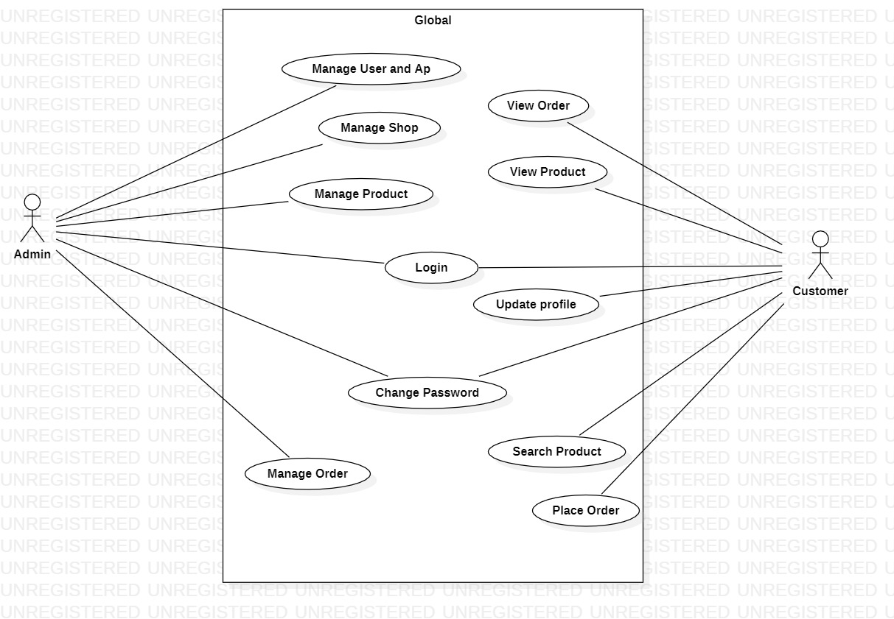

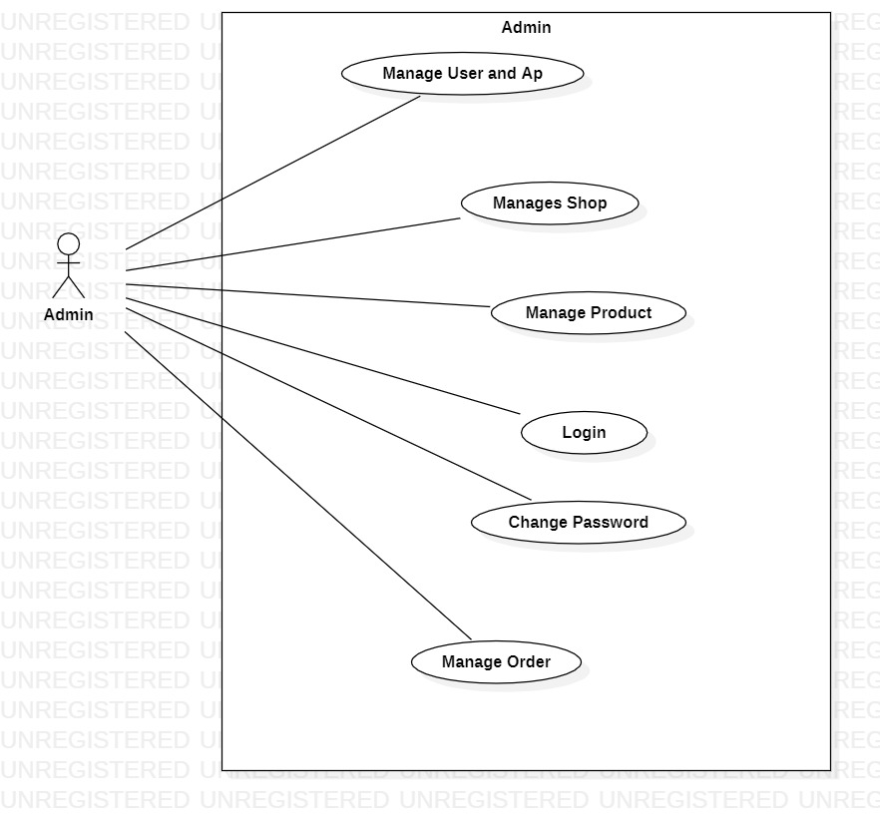 **1.2: Admin Use Case:**

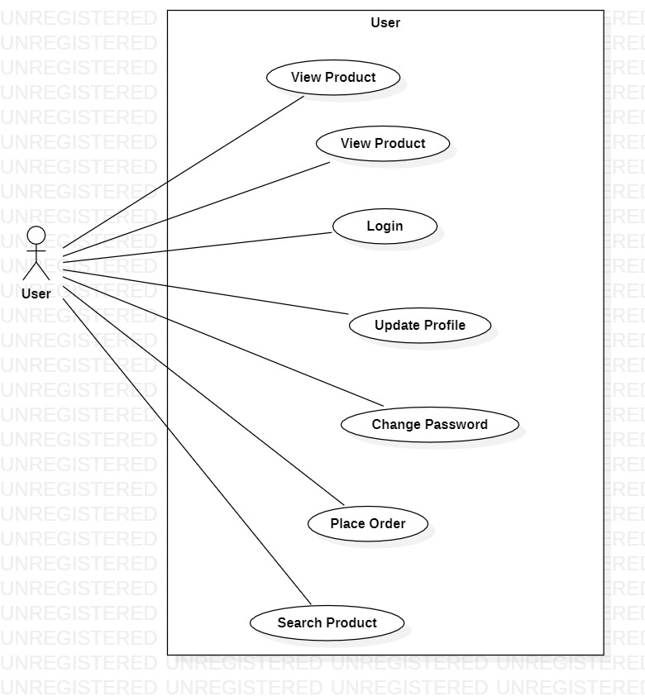 **1.3:User Use Case:**

**3.5: Class Diagram:**

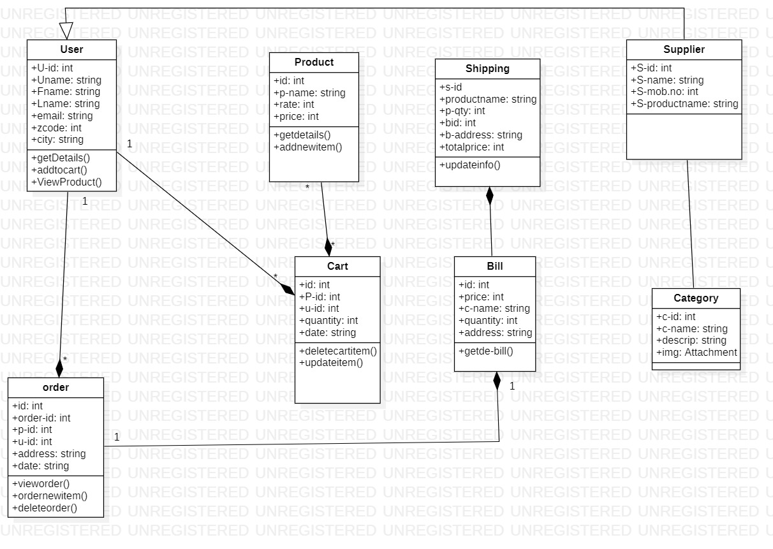

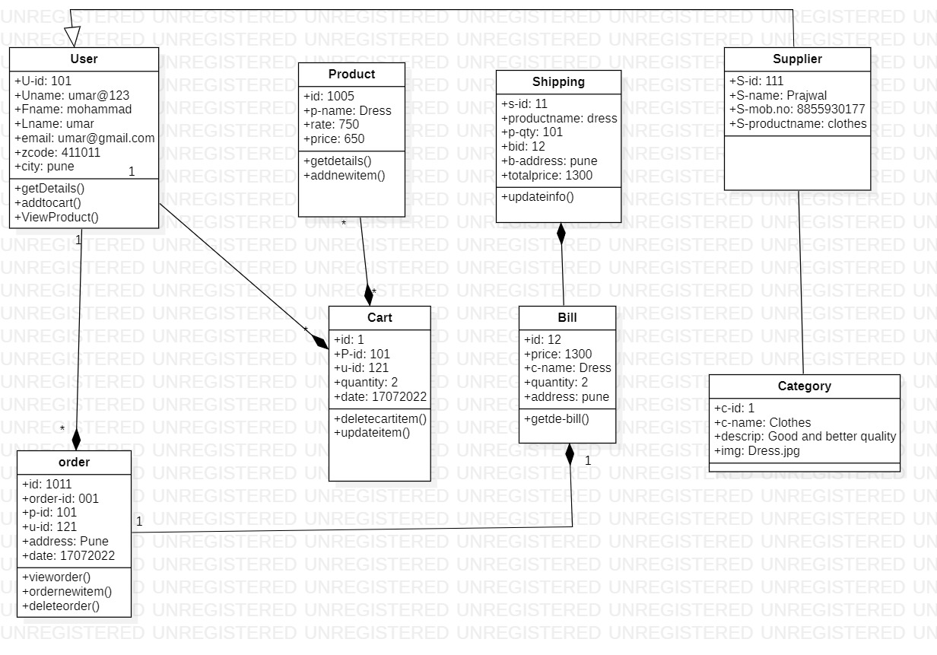**Object Diagram:**

**3.6 : Activity Diagram:**

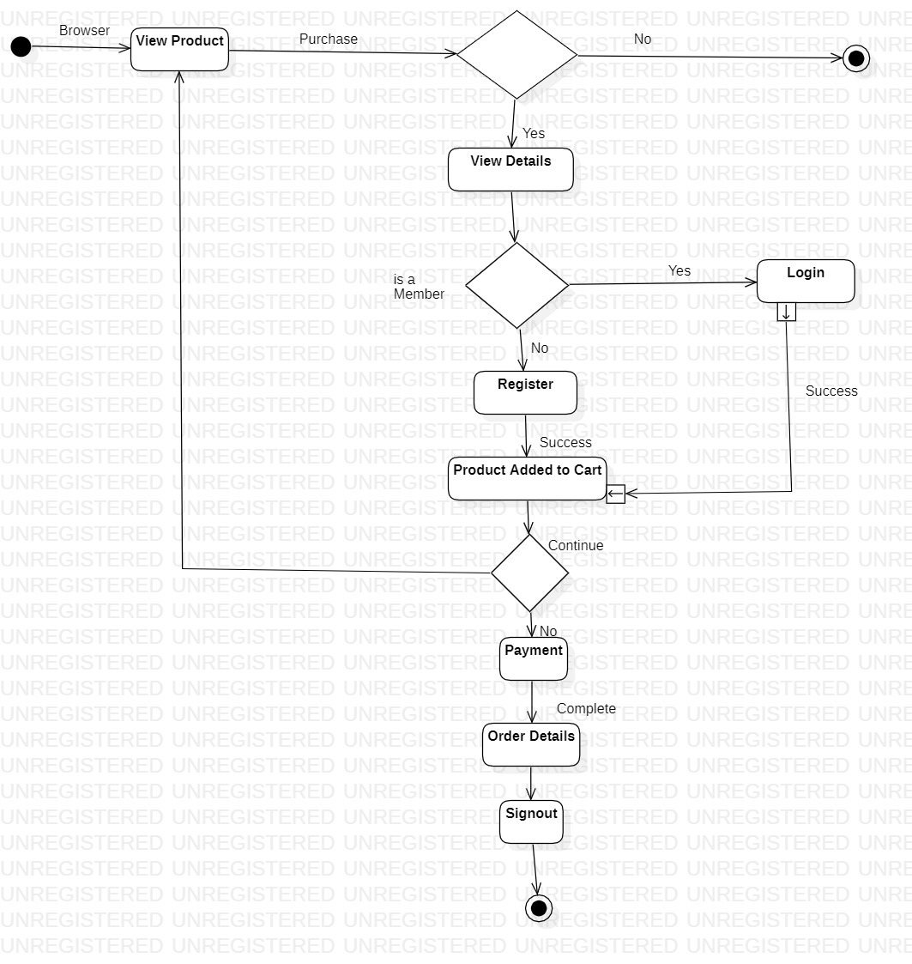

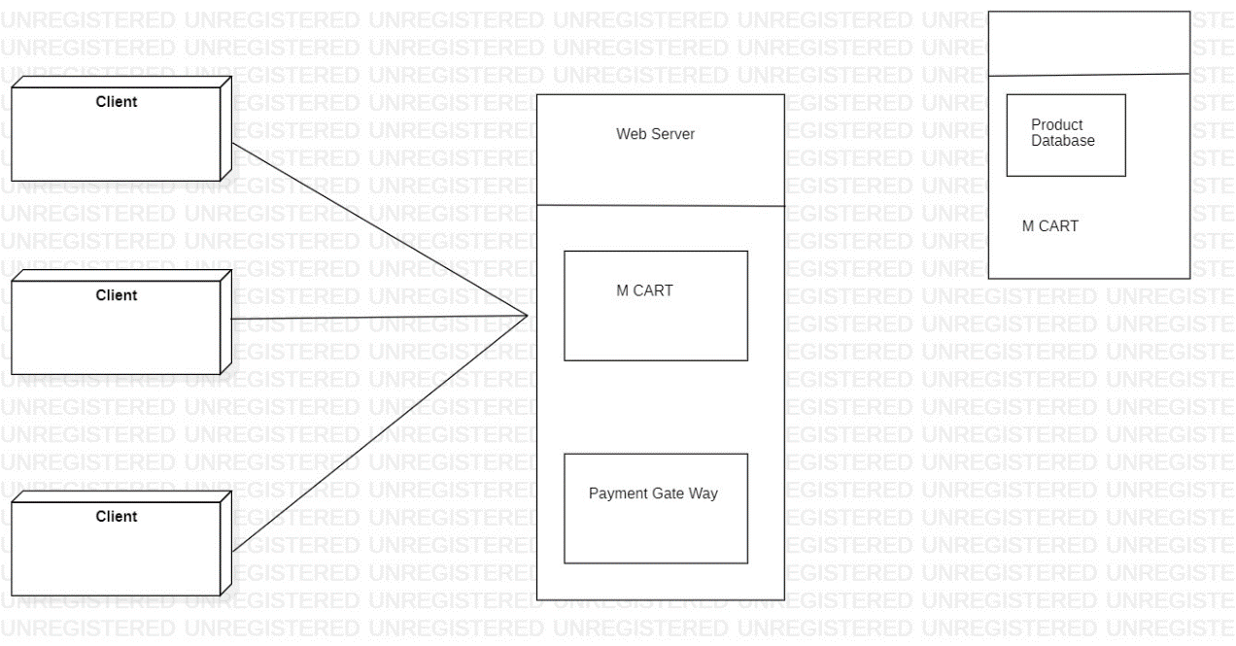**3.7:Deployment Diagram:**

**3.8:Screen Shot**

**1.1: Home Screen**

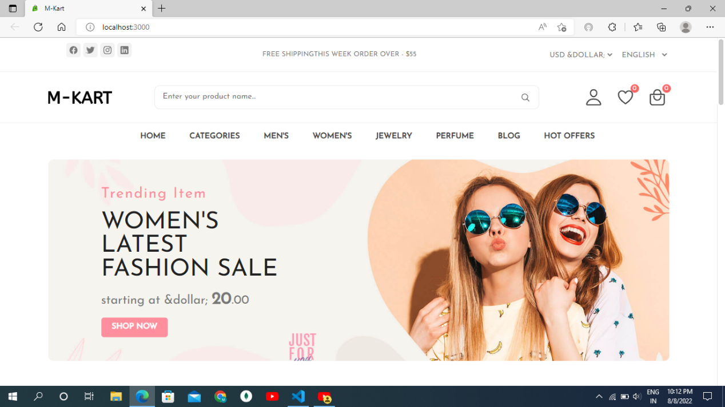

This Is Home Screen of the M-KART Shopping Store.

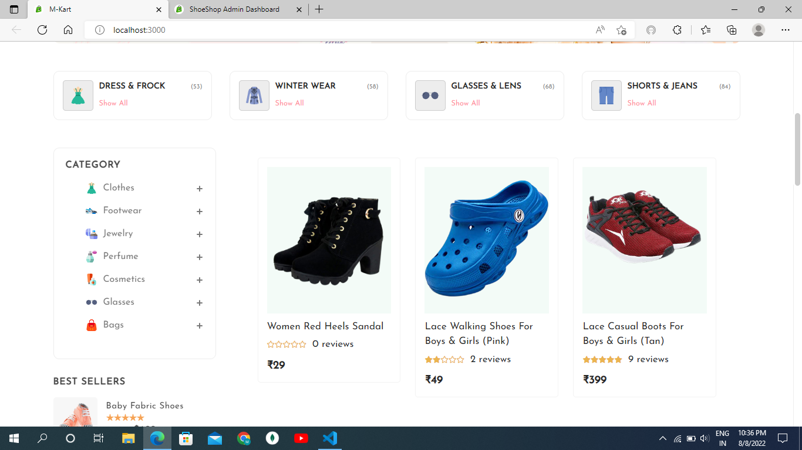

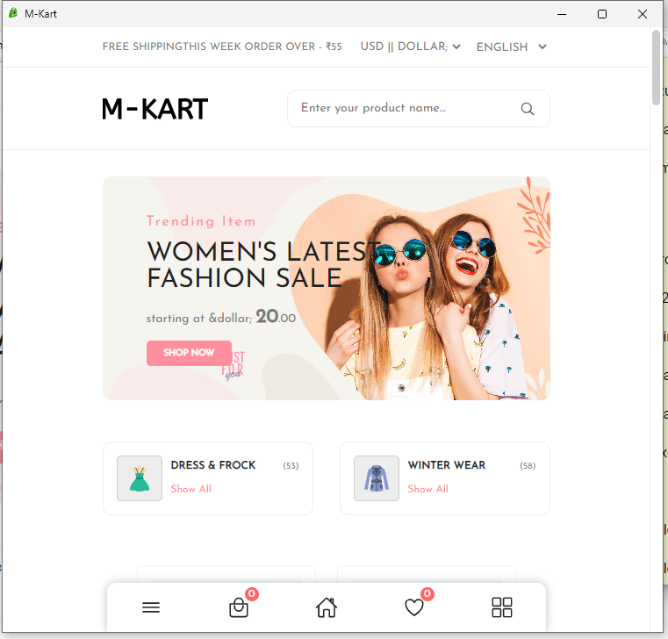This Is also a home page. Where Products are display and diffrenet option are available.

This is Mobile view of the M-KART Shopping Website app.

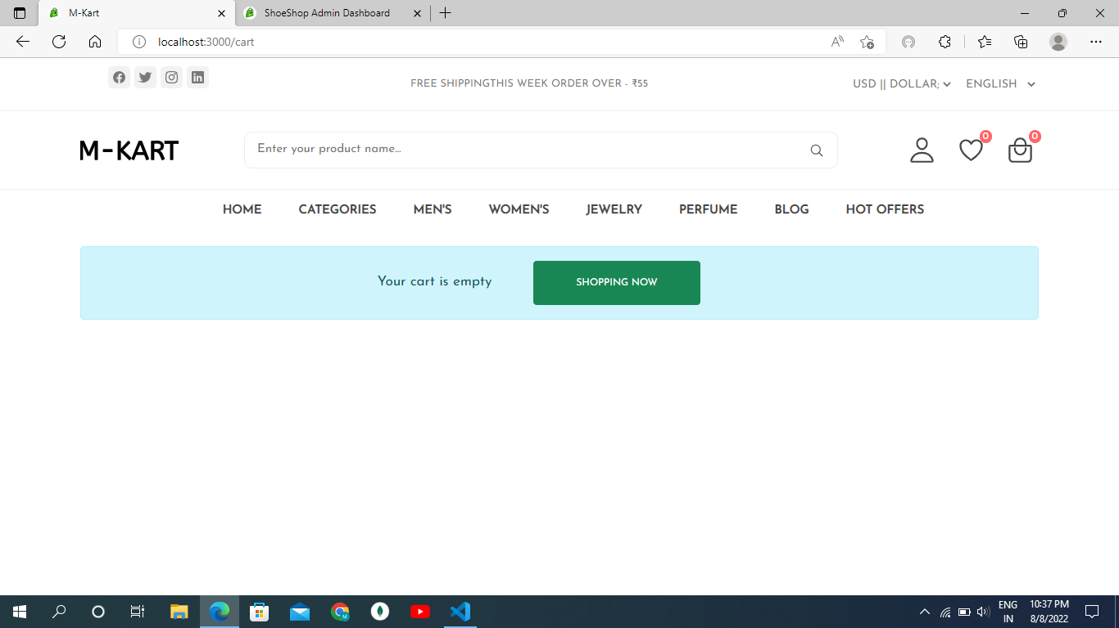

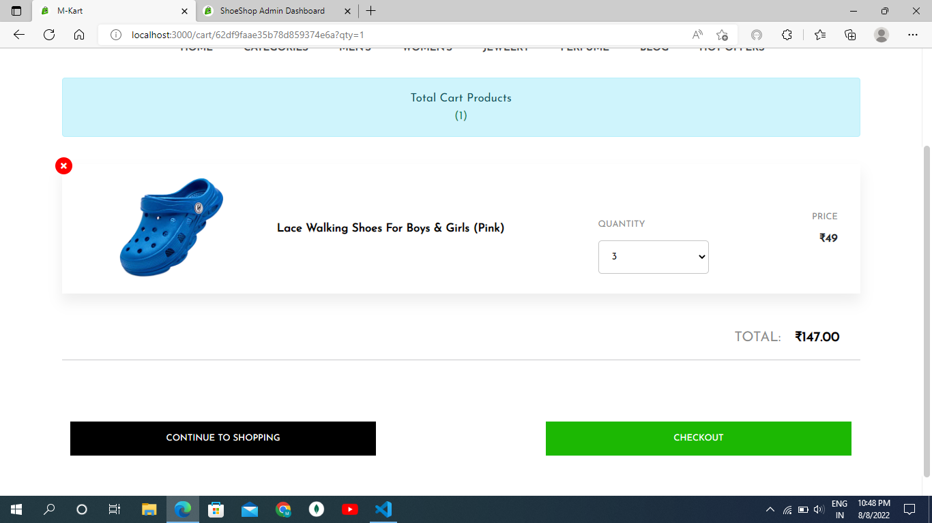

This is Cart Page.in above images one are without item in the cart showing empty cart.

And in other image show cart with product and different option like continues shopping and checkout the products.

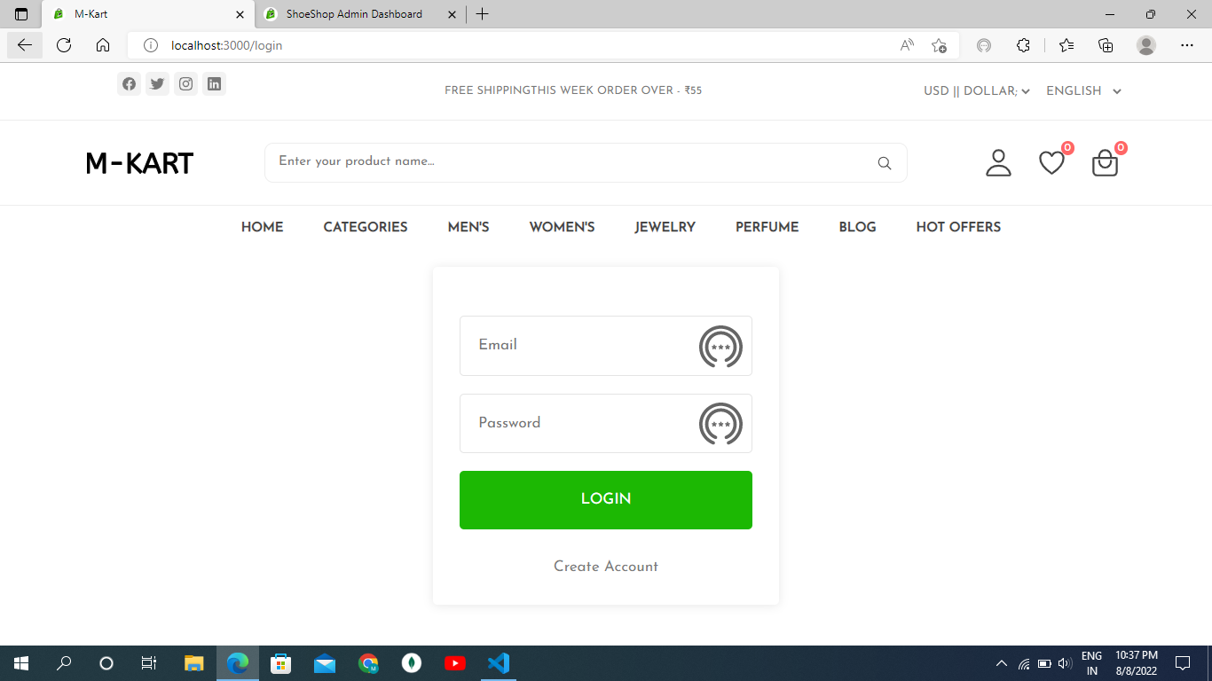

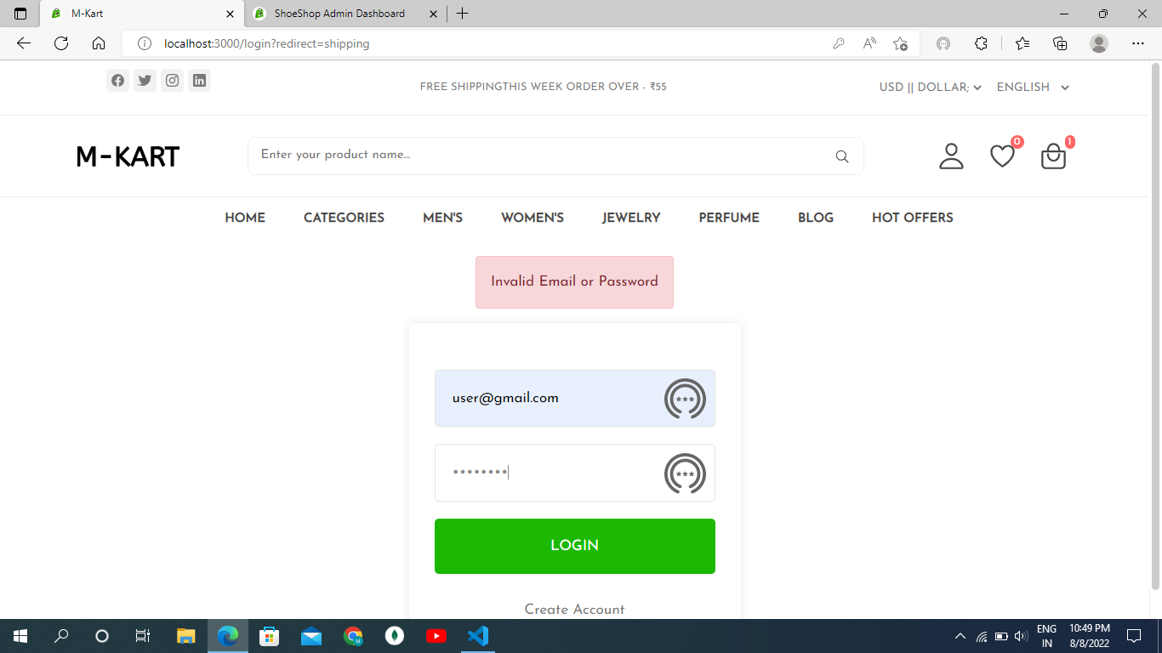

This is login page.by using this page customer login in the system and see and purches any product from the store.

Login page check the user Validation that mean user is valid or not.

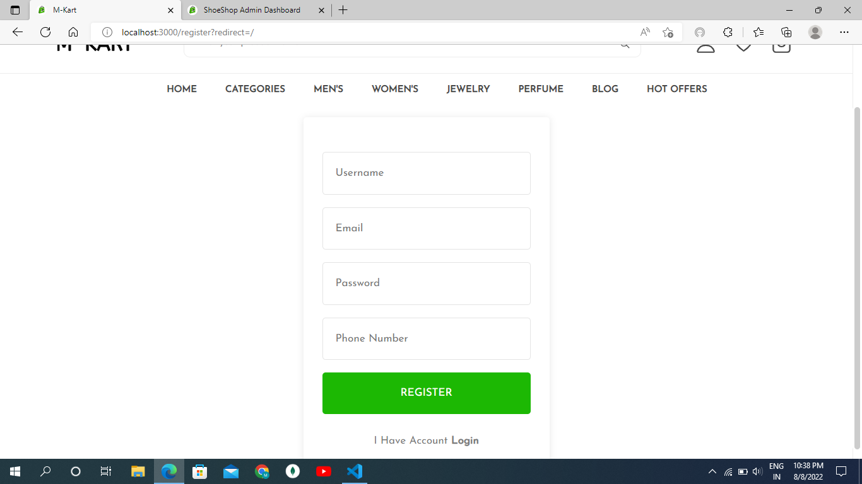

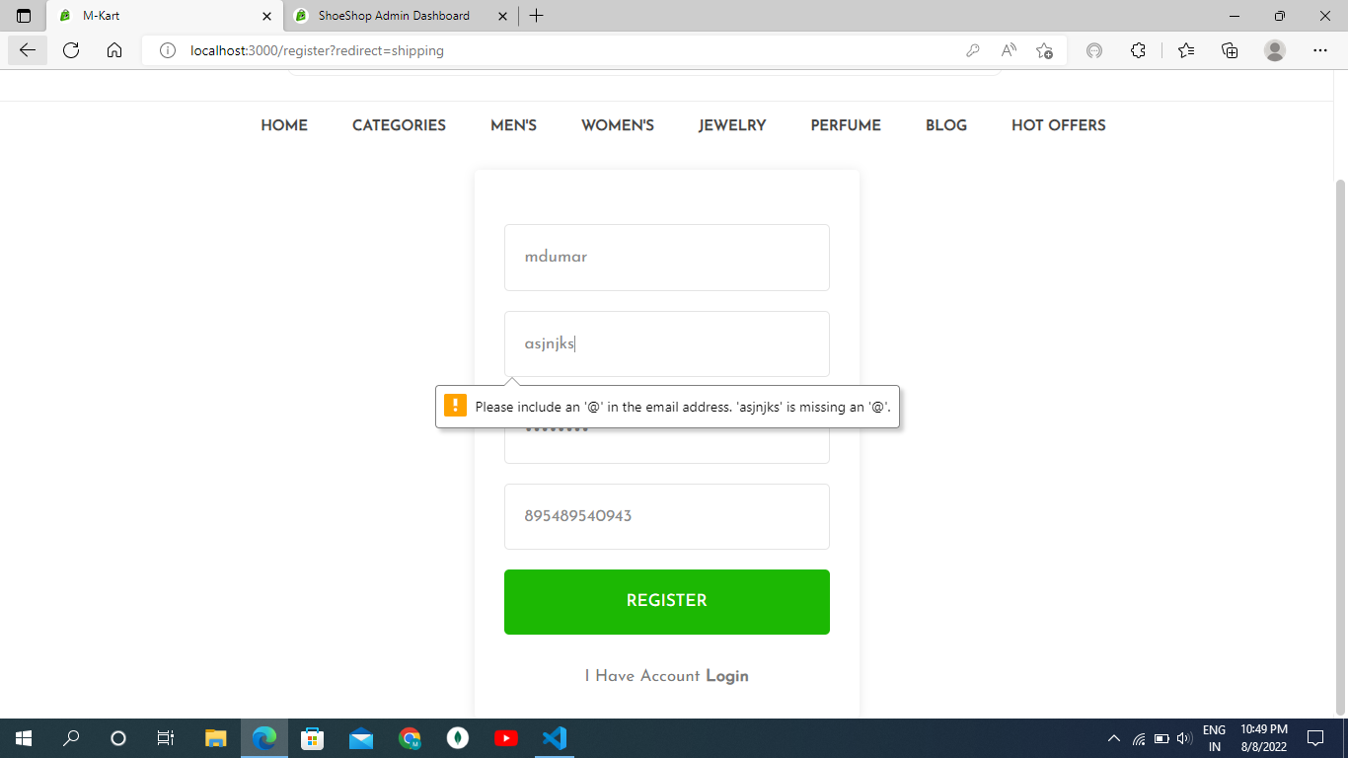

This is registration page.By using this page user can resgiter on a system and get user id and password by using the information user login into system and placeorder.

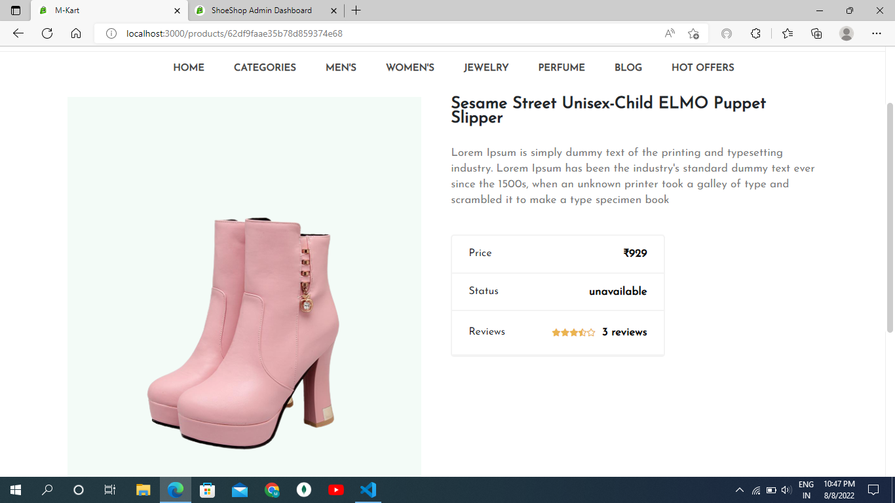

This is singla product view page.

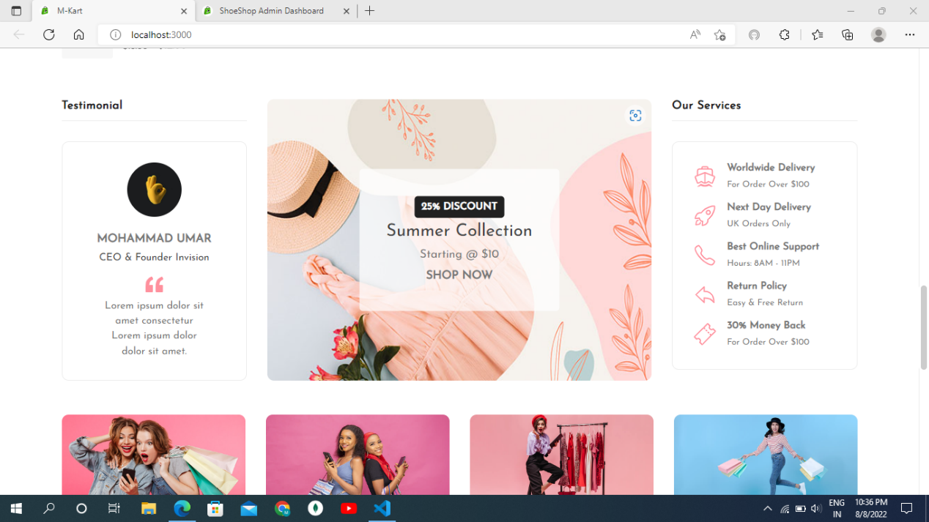

This page show the information about the system and owern of the store.

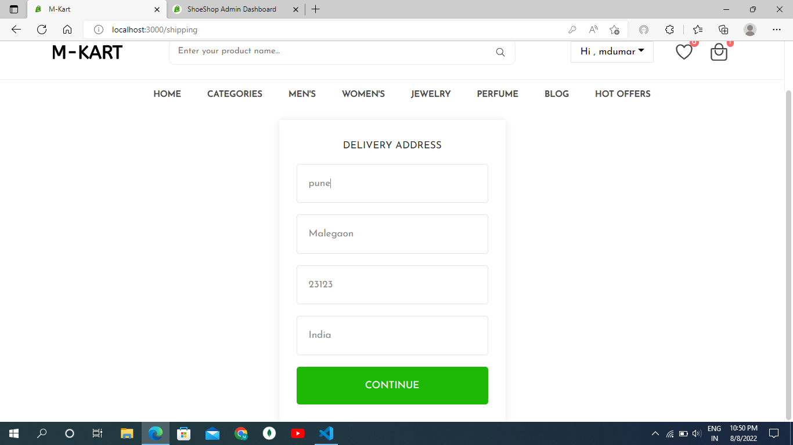

This is address page.Here user can enter there address detail where they can recived product dilavery .

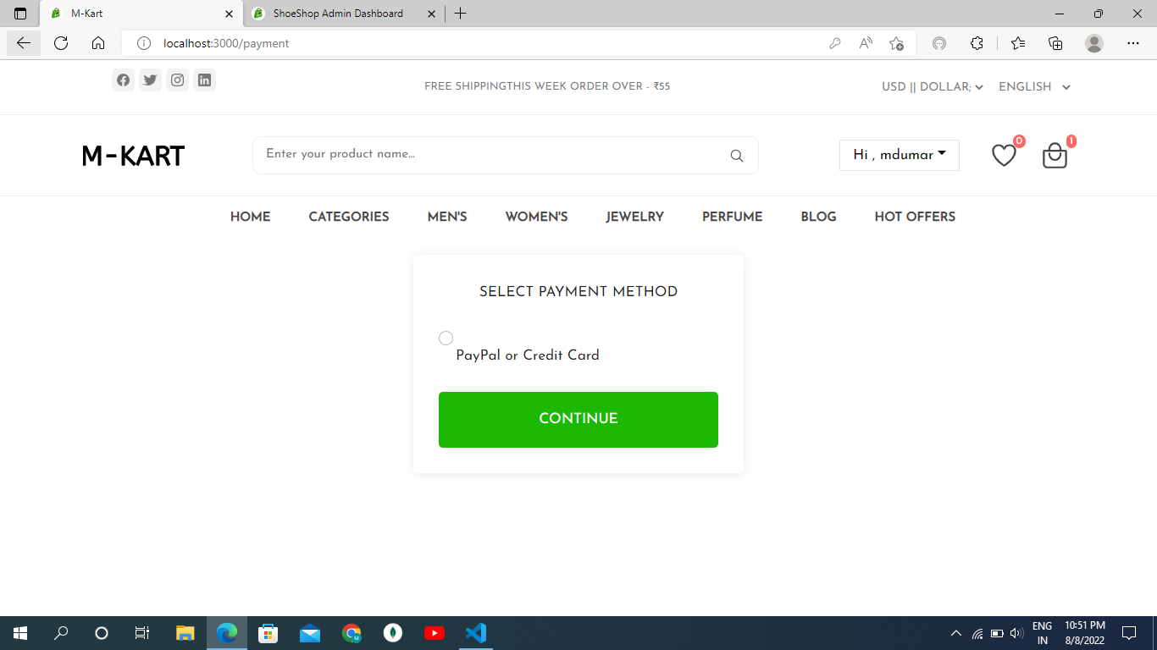

This is payment option selection method.

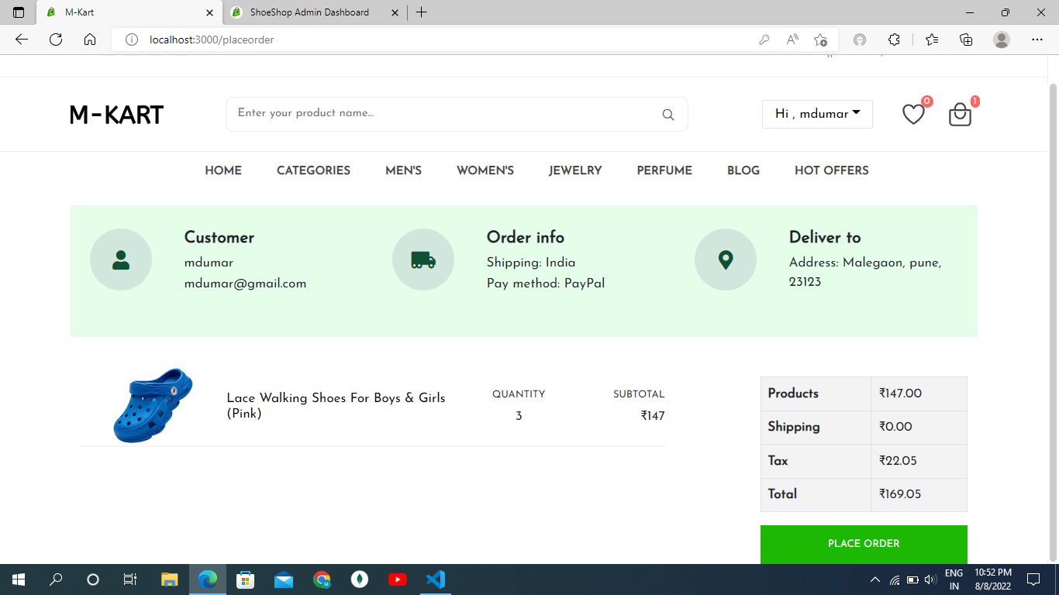

This placeorder page where user can pay payment.

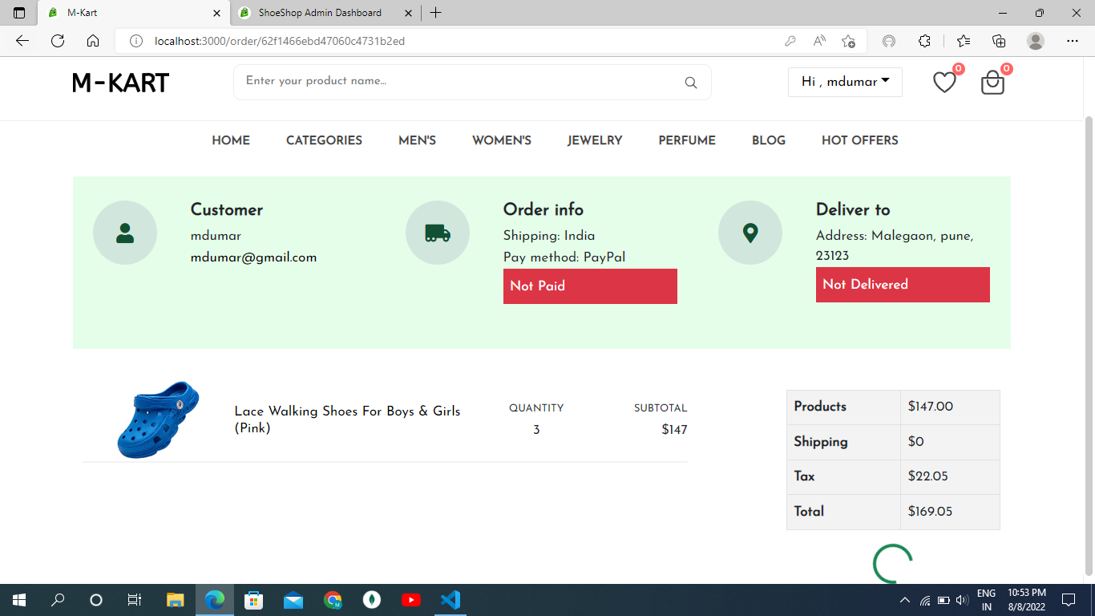

This is page show detail about the product which one we buy.

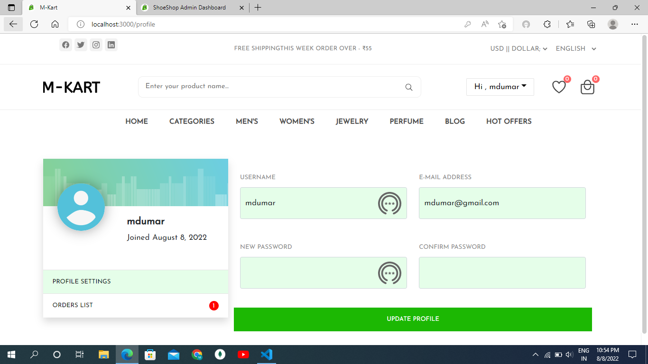

User Profile Page.

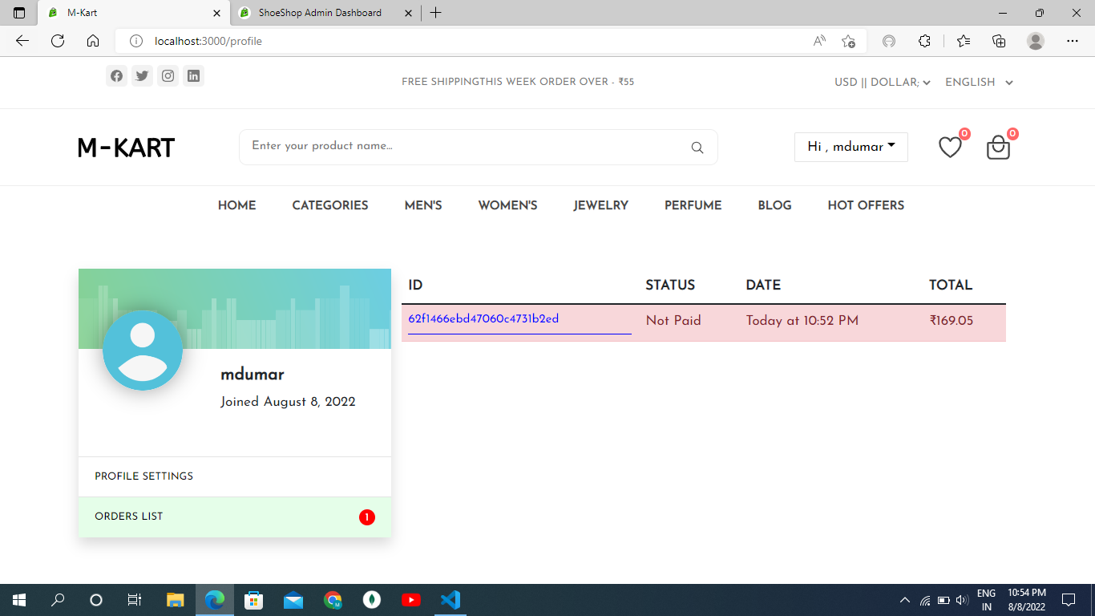

Show user Order list.

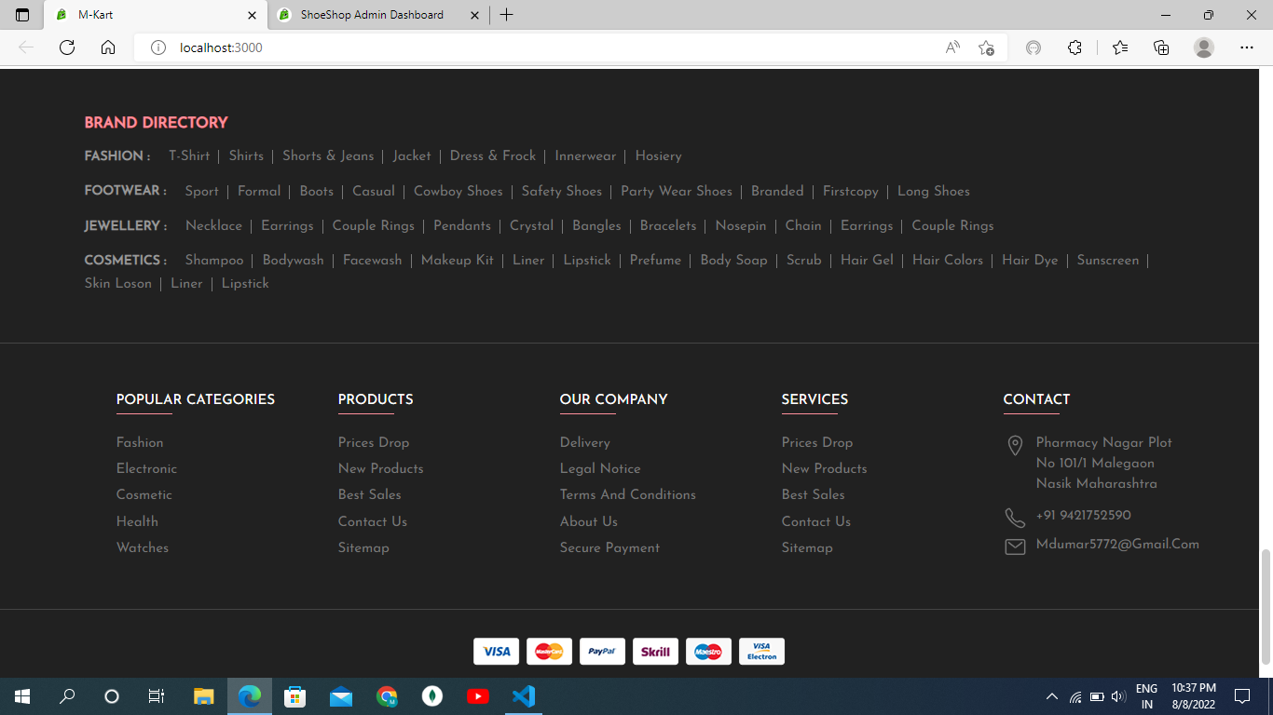

Footer of the M-KART Online shopping Store.

Admin Site Screen Shot.

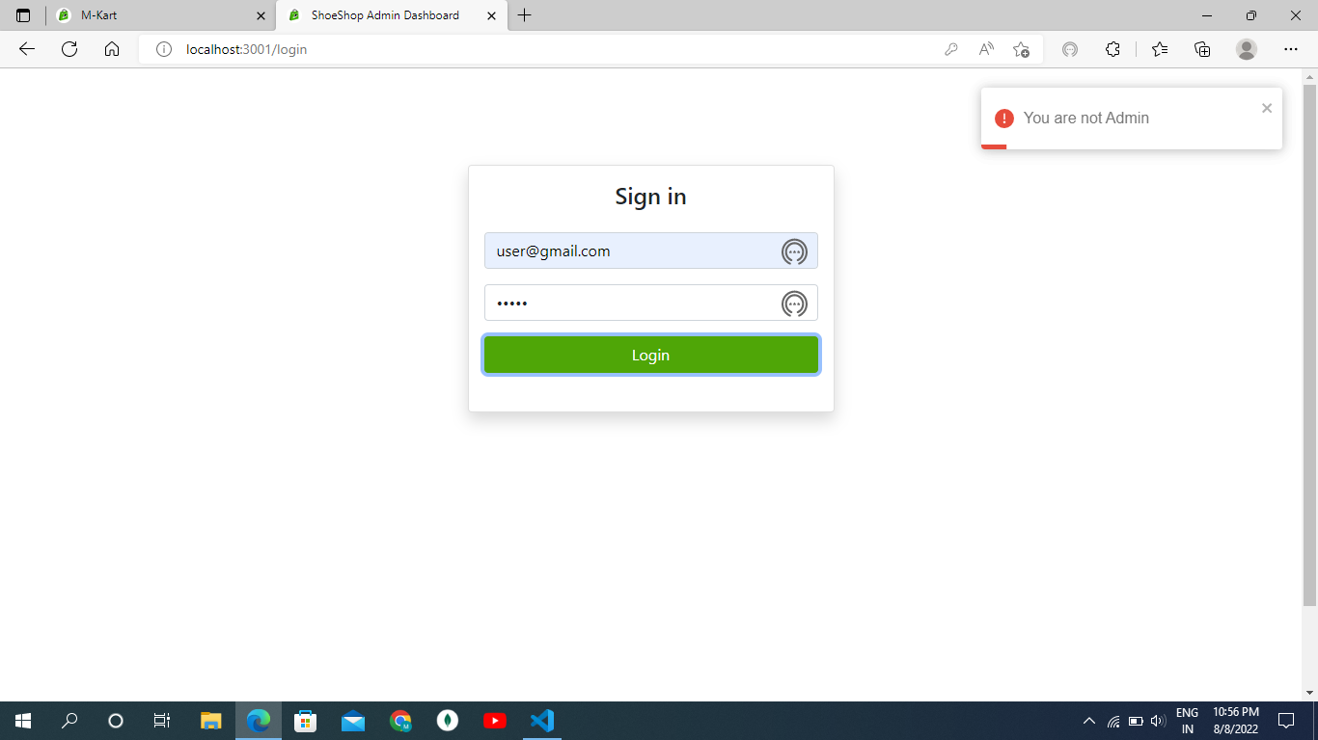

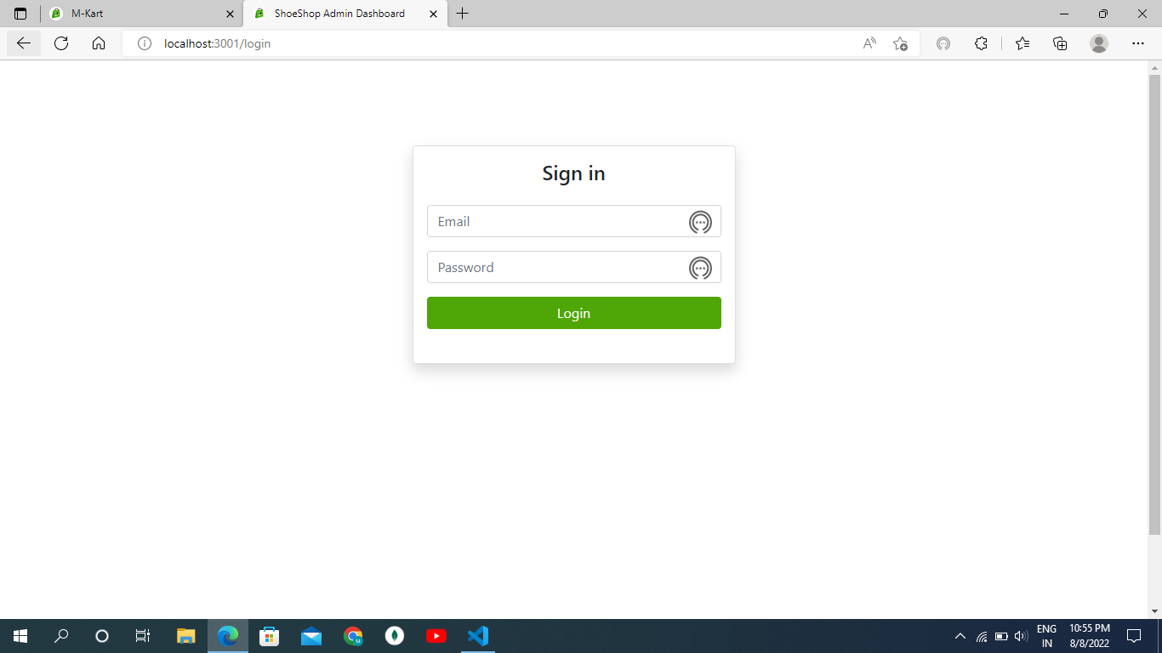

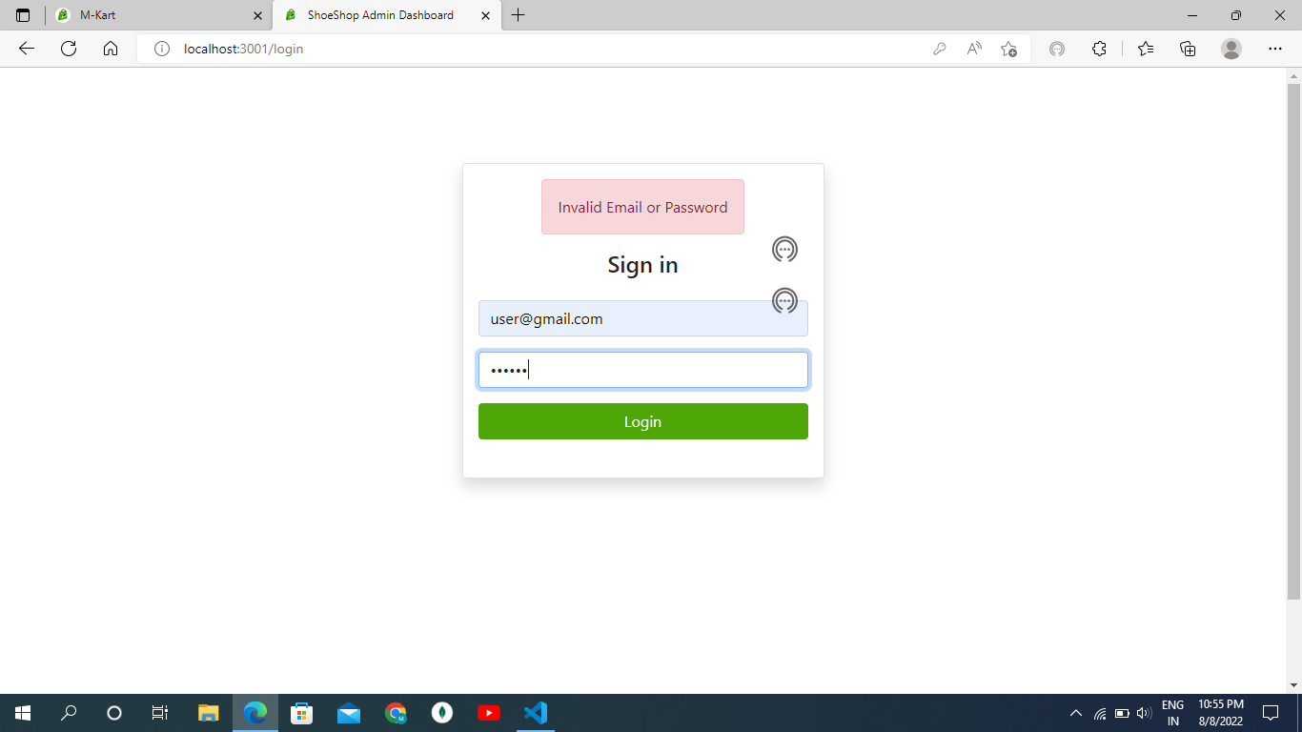

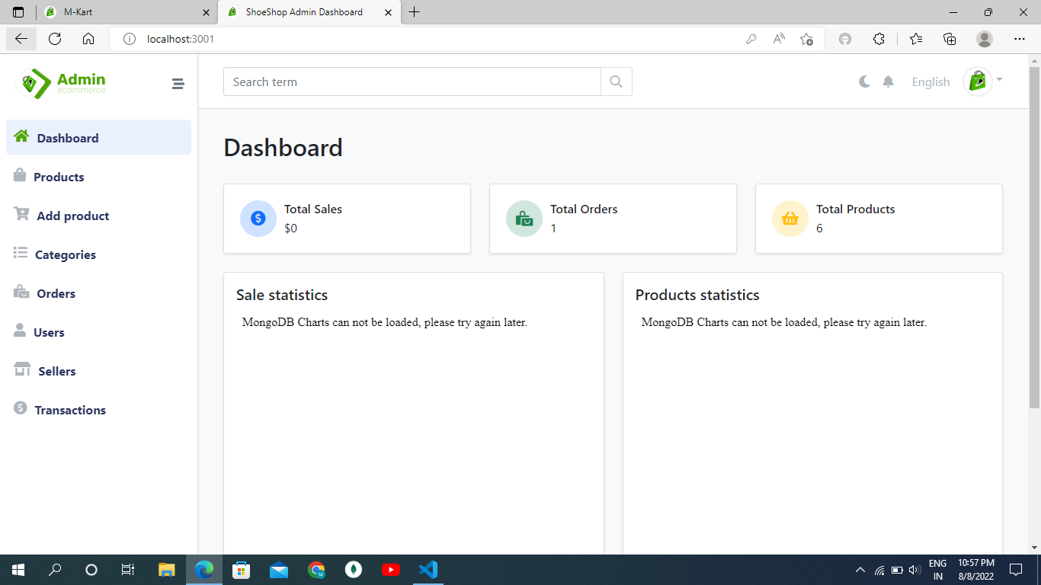

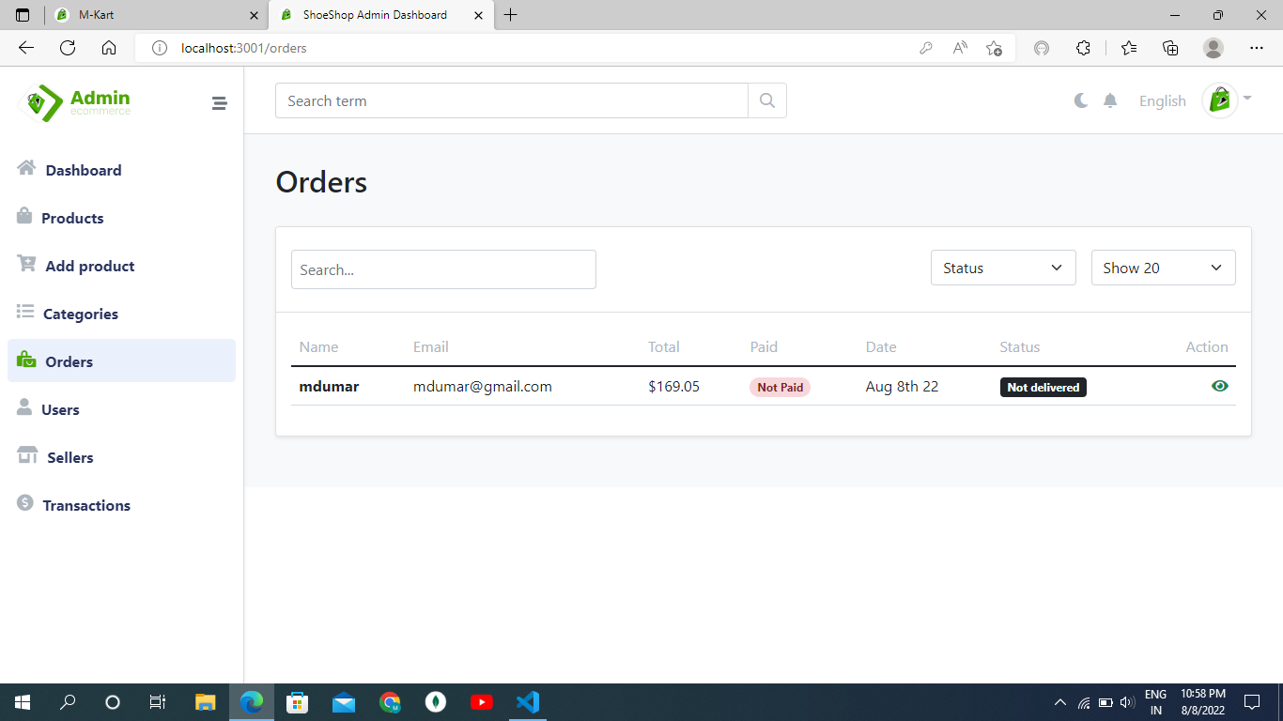

**CHAPTER 4:**

**USER MANUAL**

**4.1: Limitations Of the System:**

* The Buying and saling process usually take a customer identity which the system cannot detect.
* It required a reliable internet connection.
* Admin have to update product detail which take some time to update on user site.
* Limited payment option.

**4.2: Future Enhancement :**

* We add different payment option.
* We proviod secure dilavery option.
* Make interface user friendly and easy to access.

**4.3: BIBLOGRAPHY:**

* + **www.w3school.com**
  + **www.javatpoint.com**
  + **www.Pirple.com**

**BOOK:**

* The Joy of PHP: A Beginner’s Guide to Programming Interactive Web Applications with PHP and MySQL
* Learning PHP, MySQL & JavaScript: A Step by Step Guide to Creating Dynamic Websites 6th edition by Robin Nixon.
* Head First PHP&MySQL : By Lynn Beighley & Michael Morrison
* HTML 5 Foundations: By Matt West 3rd Edition 2013
* UML A Beginner’s Guide : Jason T. Roff 3rd Edition.

**4.4:Sample Code:**

import React, { useEffect } from "react";

import { Link } from "react-router-dom";

import Rating from "./Rating";

import Pagination from "./pagination";

import { useDispatch, useSelector } from "react-redux";

import { listProduct } from "../../Redux/Actions/ProductActions";

import Loading from "../LoadingError/Loading";

import Message from "../LoadingError/Error";

const ShopSection = (props) => {

  const { keyword, pagenumber } = props;

  const dispatch = useDispatch();

  const productList = useSelector((state) => state.productList);

  const { loading, error, products, page, pages } = productList;

  useEffect(() => {

    dispatch(listProduct(keyword, pagenumber));

  }, [dispatch, keyword, pagenumber]);

  return (

    <>

      <div >

      <div className="banner">

      <div className="container">

        <div className="slider-container has-scrollbar">

          <div className="slider-item">

            <img src="./images/banner-1.jpg" alt="women's latest fashion sale" className="banner-img"/>

            <div className="banner-content">

              <p className="banner-subtitle">Trending item</p>

              <h2 className="banner-title">Women's latest fashion sale</h2>

              <p className="banner-text">

                starting at &dollar; <b>20</b>.00

              </p>

              <Link to="/#" className="banner-btn">Shop now</Link>

            </div>

          </div>

          <div className="slider-item">

            <img src="./images/banner-2.jpg" alt="modern sunglasses" className="banner-img"/>

            <div className="banner-content">

              <p className="banner-subtitle">Trending accessories</p>

              <h2 className="banner-title">Modern sunglasses</h2>

              <p className="banner-text">

                starting at &dollar; <b>15</b>.00

              </p>

              <Link to="/#" className="banner-btn">Shop now</Link>

            </div>

          </div>

          <div className="slider-item">

            <img src="./images/banner-3.jpg" alt="new fashion summer sale" className="banner-img"/>

            <div className="banner-content">

              <p className="banner-subtitle">Sale Offer</p>

              <h2 className="banner-title">New fashion summer sale</h2>

              <p className="banner-text">

                starting at &dollar; <b>29</b>.99

              </p>

              <Link to="/#" className="banner-btn">Shop now</Link>

            </div>

          </div>

        </div>

      </div>

      </div>

      <div className="category">

      <div className="container">

        <div className="category-item-container has-scrollbar">

          <div className="category-item">

            <div className="category-img-box">

              <img src="./images/icons/dress.svg" alt="dress and frock" width="30"/>

            </div>

            <div className="category-content-box">

              <div className="category-content-flex">

                <h3 className="category-item-title">Dress & frock</h3>

                <p className="category-item-amount">(53)</p>

              </div>

              <Link to="/#" className="category-btn">Show all</Link>

            </div>

          </div>

          <div className="category-item">

            <div className="category-img-box">

              <img src="./images/icons/coat.svg" alt="winter wear" width="30"/>

            </div>

            <div className="category-content-box">

              <div className="category-content-flex">

                <h3 className="category-item-title">Winter wear</h3>

                <p className="category-item-amount">(58)</p>

              </div>

              <Link to="/#" className="category-btn">Show all</Link>

            </div>

          </div>

          <div className="category-item">

            <div className="category-img-box">

              <img src="./images/icons/glasses.svg" alt="glasses & lens" width="30"/>

            </div>

            <div className="category-content-box">

              <div className="category-content-flex">

                <h3 className="category-item-title">Glasses & lens</h3>

                <p className="category-item-amount">(68)</p>

              </div>

              <Link to="/#" className="category-btn">Show all</Link>

            </div>

          </div>

          <div className="category-item">

            <div className="category-img-box">

              <img src="./images/icons/shorts.svg" alt="shorts & jeans" width="30"/>

            </div>

            <div className="category-content-box">

              <div className="category-content-flex">

                <h3 className="category-item-title">Shorts & jeans</h3>

                <p className="category-item-amount">(84)</p>

              </div>

              <Link to="/#" className="category-btn">Show all</Link>

            </div>

          </div>

          <div className="category-item">

            <div className="category-img-box">

              <img src="./images/icons/tee.svg" alt="t-shirts" width="30"/>

            </div>

            <div className="category-content-box">

              <div className="category-content-flex">

                <h3 className="category-item-title">T-shirts</h3>

                <p className="category-item-amount">(35)</p>

              </div>

              <Link to="/#" className="category-btn">Show all</Link>

            </div>

          </div>

          <div className="category-item">

            <div className="category-img-box">

              <img src="./images/icons/jacket.svg" alt="jacket" width="30"/>

            </div>

            <div className="category-content-box">

              <div className="category-content-flex">

                <h3 className="category-item-title">Jacket</h3>

                <p className="category-item-amount">(16)</p>

              </div>

              <Link to="/#" className="category-btn">Show all</Link>

            </div>

          </div>

          <div className="category-item">

            <div className="category-img-box">

              <img src="./images/icons/watch.svg" alt="watch" width="30"/>

            </div>

            <div className="category-content-box">

              <div className="category-content-flex">

                <h3 className="category-item-title">Watch</h3>

                <p className="category-item-amount">(27)</p>

              </div>

              <Link to="/#" className="category-btn">Show all</Link>

            </div>

          </div>

          <div className="category-item">

            <div className="category-img-box">

              <img src="./images/icons/hat.svg" alt="hat & caps" width="30"/>

            </div>

            <div className="category-content-box">

              <div className="category-content-flex">

                <h3 className="category-item-title">Hat & caps</h3>

                <p className="category-item-amount">(39)</p>

              </div>

              <Link to="/#" className="category-btn">Show all</Link>

            </div>

          </div>

        </div>

      </div>

      </div>

        {/* <img className="centre" src="./public/images/_8.png" alt="" srcset="" />

        <img

          className="badge rotate"

          src="./public/images/badge.svg"

          alt=""

          srcset=""

        /> */}

      </div>

      <div class="product-container">

      <div class="container">

        <div class="sidebar  has-scrollbar" data-mobile-menu>

          <div class="sidebar-category">

            <div class="sidebar-top">

              <h2 class="sidebar-title">Category</h2>

              <button class="sidebar-close-btn" data-mobile-menu-close-btn>

                <ion-icon  name="close-outline"></ion-icon>

              </button>

            </div>

            <ul className="sidebar-menu-category-list">

              <li className="sidebar-menu-category">

                <button className="sidebar-accordion-menu" data-accordion-btn>

                  <div class="menu-title-flex">

                    <img src="./images/icons/dress.svg" alt="clothes" width="20" height="20"

                      class="menu-title-img"/>

                    <p className="menu-title">Clothes</p>

                  </div>

                  <div>

                    <ion-icon name="add-outline" class="add-icon"></ion-icon>

                    <ion-icon name="remove-outline" class="remove-icon"></ion-icon>

                  </div>

                </button>

                <ul className="sidebar-submenu-category-list" data-accordion>

                  <li className="sidebar-submenu-category">

                    <Link to="/#" className="sidebar-submenu-title">

                      <p className="product">Shirt</p>

                      <data value="300" class="stock" title="Available Stock">300</data>

                    </Link>

                  </li>

                  <li class="sidebar-submenu-category">

                    <Link to="/#" class="sidebar-submenu-title">

                      <p class="product">shorts & jeans</p>

                      <data value="60" class="stock" title="Available Stock">60</data>

                    </Link>

                  </li>

                  <li class="sidebar-submenu-category">

                    <Link to="/#" class="sidebar-submenu-title">

                      <p class="product">jacket</p>

                      <data value="50" class="stock" title="Available Stock">50</data>

                    </Link>

                  </li>

                  <li class="sidebar-submenu-category">

                    <Link to="/#" class="sidebar-submenu-title">

                      <p class="product">dress & frock</p>

                      <data value="87" class="stock" title="Available Stock">87</data>

                    </Link>

                  </li>

                </ul>

              </li>

              <li class="sidebar-menu-category">

                <button class="sidebar-accordion-menu" data-accordion-btn>

                  <div class="menu-title-flex">

                    <img src="./images/icons/shoes.svg" alt="footwear" class="menu-title-img" width="20"

                      height="20"/>

                    <p class="menu-title">Footwear</p>

                  </div>

                  <div>

                    <ion-icon name="add-outline" class="add-icon"></ion-icon>

                    <ion-icon name="remove-outline" class="remove-icon"></ion-icon>

                  </div>

                </button>

                <ul class="sidebar-submenu-category-list" data-accordion>

                  <li class="sidebar-submenu-category">

                    <Link to="/#" class="sidebar-submenu-title">

                      <p class="product">Sports</p>

                      <data value="45" class="stock" title="Available Stock">45</data>

                    </Link>

                  </li>

                  <li class="sidebar-submenu-category">

                    <Link to="/#" class="sidebar-submenu-title">

                      <p class="product">Formal</p>

                      <data value="75" class="stock" title="Available Stock">75</data>

                    </Link>

                  </li>

                  <li class="sidebar-submenu-category">

                    <Link to="/#" class="sidebar-submenu-title">

                      <p class="product">Casual</p>

                      <data value="35" class="stock" title="Available Stock">35</data>

                    </Link>

                  </li>

                  <li class="sidebar-submenu-category">

                    <Link to="/#" class="sidebar-submenu-title">

                      <p class="product">Safety Shoes</p>

                      <data value="26" class="stock" title="Available Stock">26</data>

                    </Link>

                  </li>

                </ul>

              </li>

              <li class="sidebar-menu-category">

                <button class="sidebar-accordion-menu" data-accordion-btn>

                  <div class="menu-title-flex">

                    <img src="./images/icons/jewelry.svg" alt="clothes" class="menu-title-img" width="20"

                      height="20"/>

                    <p class="menu-title">Jewelry</p>

                  </div>

                  <div>

                    <ion-icon name="add-outline" class="add-icon"></ion-icon>

                    <ion-icon name="remove-outline" class="remove-icon"></ion-icon>

                  </div>

                </button>

                <ul class="sidebar-submenu-category-list" data-accordion>

                  <li class="sidebar-submenu-category">

                    <Link to="/#" class="sidebar-submenu-title">

                      <p class="product">Earrings</p>

                      <data value="46" class="stock" title="Available Stock">46</data>

                    </Link>

                  </li>

                  <li class="sidebar-submenu-category">

                    <Link to="/#" class="sidebar-submenu-title">

                      <p class="product">Couple Rings</p>

                      <data value="73" class="stock" title="Available Stock">73</data>

                    </Link>

                  </li>

                  <li class="sidebar-submenu-category">

                    <Link to="/#" class="sidebar-submenu-title">

                      <p class="product">Necklace</p>

                      <data value="61" class="stock" title="Available Stock">61</data>

                    </Link>

                  </li>

                </ul>

              </li>

              <li class="sidebar-menu-category">

                <button class="sidebar-accordion-menu" data-accordion-btn>

                  <div class="menu-title-flex">

                    <img src="./images/icons/perfume.svg" alt="perfume" class="menu-title-img" width="20"

                      height="20"/>

                    <p class="menu-title">Perfume</p>

                  </div>

                  <div>

                    <ion-icon name="add-outline" class="add-icon"></ion-icon>

                    <ion-icon name="remove-outline" class="remove-icon"></ion-icon>

                  </div>

                </button>

                <ul class="sidebar-submenu-category-list" data-accordion>

                  <li class="sidebar-submenu-category">

                    <Link to="/#" class="sidebar-submenu-title">

                      <p class="product">Clothes Perfume</p>

                      <data value="12" class="stock" title="Available Stock">12 pcs</data>

                    </Link>

                  </li>

                  <li class="sidebar-submenu-category">

                    <Link to="/#" class="sidebar-submenu-title">

                      <p class="product">Deodorant</p>

                      <data value="60" class="stock" title="Available Stock">60 pcs</data>

                    </Link>

                  </li>

                  <li class="sidebar-submenu-category">

                    <Link to="/#" class="sidebar-submenu-title">

                      <p class="product">jacket</p>

                      <data value="50" class="stock" title="Available Stock">50 pcs</data>

                    </Link>

                  </li>

                  <li class="sidebar-submenu-category">

                    <Link to="/#" class="sidebar-submenu-title">

                      <p class="product">dress & frock</p>

                      <data value="87" class="stock" title="Available Stock">87 pcs</data>

                    </Link>

                  </li>

                </ul>

              </li>

              <li class="sidebar-menu-category">

                <button class="sidebar-accordion-menu" data-accordion-btn>

                  <div class="menu-title-flex">

                    <img src="./images/icons/cosmetics.svg" alt="cosmetics" class="menu-title-img" width="20"

                      height="20"/>

                    <p class="menu-title">Cosmetics</p>

                  </div>

                  <div>

                    <ion-icon name="add-outline" class="add-icon"></ion-icon>

                    <ion-icon name="remove-outline" class="remove-icon"></ion-icon>

                  </div>

                </button>

                <ul class="sidebar-submenu-category-list" data-accordion>

                  <li class="sidebar-submenu-category">

                    <Link to="/#" class="sidebar-submenu-title">

                      <p class="product">Shampoo</p>

                      <data value="68" class="stock" title="Available Stock">68</data>

                    </Link>

                  </li>

                  <li class="sidebar-submenu-category">

                    <Link to="/#" class="sidebar-submenu-title">

                      <p class="product">Sunscreen</p>

                      <data value="46" class="stock" title="Available Stock">46</data>

                    </Link>

                  </li>

                  <li class="sidebar-submenu-category">

                    <Link to="/#" class="sidebar-submenu-title">

                      <p class="product">Body Wash</p>

                      <data value="79" class="stock" title="Available Stock">79</data>

                    </Link>

                  </li>

                  <li class="sidebar-submenu-category">

                    <Link to="/#" class="sidebar-submenu-title">

                      <p class="product">Makeup Kit</p>

                      <data value="23" class="stock" title="Available Stock">23</data>

                    </Link>

                  </li>

                </ul>

              </li>

              <li class="sidebar-menu-category">

                <button class="sidebar-accordion-menu" data-accordion-btn>

                  <div class="menu-title-flex">

                    <img src="./images/icons/glasses.svg" alt="glasses" class="menu-title-img" width="20"

                      height="20"/>

                    <p class="menu-title">Glasses</p>

                  </div>

                  <div>

                    <ion-icon name="add-outline" class="add-icon"></ion-icon>

                    <ion-icon name="remove-outline" class="remove-icon"></ion-icon>